

**Unit Name:** Network Security and Resilience

**Unit Code:** TNE30009

**Title:** NSR/AS Lab 3 – VPNs

**Name:** S M RAGIB REZWAN

**ID:** 103172423

Contents

[Abstract: 2](#_Toc132938232)

[Introduction to VPNs: 2](#_Toc132938233)

[OpenVPN behaviour: 3](#_Toc132938234)

[Conclusion 8](#_Toc132938235)

[References 8](#_Toc132938236)

# 

# Abstract:

This is a lab report based upon TNE30009’s week 6’s lab3 task **[1]** on OpenVPN. It begins with an “Introduction to VPNs” section which contains brief background on VPN tunnels, its tunneling protocols and its relevance in implementing Organizational Security Policy. After this, it leads to the “OpenVPN behavior” section which explains what OpenVPN is, how to set up the VPN tunnel (along with screenshot of the steps’ outcomes for visualization) and how traffic is passed between the interfaces. Lastly, it has the “Conclusion” section where it wraps everything up as a brief summary.

# Introduction to VPNs:

VPN is basically a mechanism that is used to create a secure network over an existing insecure communication medium (like Internet) **[2]**. It does this by creating a tunnel that connects two end points (mimicking a point to point connection) and encapsulating the packets passing through it using its own tunneling packet header.

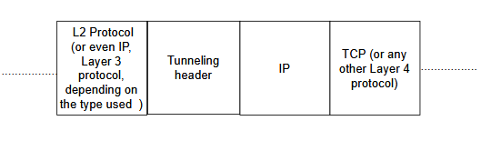

*Figure 1: Generic Headers present in packet travelling through VPN tunnel*

Here the information present in the Tunnel header varies depending on the type of protocol that has been used. This has been detailed in table1:

|  |  |  |  |
| --- | --- | --- | --- |
| Tunneling protocol | Ones who created it | Types of tunneling protocol that are used by it | Types of encryption |
| IPSec | IETF **[3]** | Authentication Header (AH), Encapsulating security payload (ESP), Internet key Exchange (IKE) | AES, Blowfish, Triple DES, ChaCha, DES-CBC |
| PPTP | Microsoft, Ascend Communication, 3Com/Primary Access, ECI Telematics, and US Robotics **[4]** | PPP datagrams (to encapsulate IPX, NetBEUI, TCP/IP packets) | Remote access service(RAS) shared-secret, PPP encryption and RSA’s RC4 (Rivest Cipher 4) |
| L2TP | Cisco **[5]** | L2TP protocols (but can be used in conjunction to IPSec to use its protocols too ) **[6]** | It doesn’t provide any encryption on its own, but when used with IPSec, it can provide IpSec’s encryption types  **[7]** |
| SSTP | Microsoft **[8]** | SSL/TLS **[8] [9]** | AES (Advanced Encryption Standard) **[8]** |

*Table1: VPN tunneling protocols characteristic and capabilities*

But basically, no matter what type of tunneling protocol is used, VPN still provides advantages in terms of lower implementation and management costs, better connectivity, improved security, better scalability, higher efficiency, better privacy, etc. **[5]**.

Furthermore, it is also utilized in setting up the security policies in an organization. These are basically clear, comprehensive, and well-defined plans, rules, and practices that regulate access to an organization's system and the information included in it **[10]**. Hence it is quite easy to see how crucial VPN is in that regard as it ensures that only those with proper authentication and authorization can access the resources though the tunnel.

**Note:** this has been further supported by the creation of template VPN policy by the NCS (National Cybersecurity Society **[11]**) (which has been used in various companies worldwide (AWS, Apple, Dell Technologies, etc.**[12]**) in order to prevent unauthorized access to their resources, ensure data using the tunnel is properly encrypted, setup time limits for access, etc**[11]**).

# OpenVPN behaviour:

But how does OpenVPN relate to all of these?

Well, OpenVPN is basically an open–source VPN protocol that has become quite popular in recent years. It is used to not only create the point to point (or site to site) VPN connections, but also ensure proper encryption (hence security) for the packets in the tunnel with the help of OpenSSL library and SSL/TSL encryption header. Furthermore, it can also traverse both NAT and firewall with ease **[13]**.

Overall, it provides the benefits of having better security, stronger encryption and reliable connection, with the trade off in terms of speed, setup, and its 3rd party application requirements **[14]**. But even so, on average, it is still better than the other commonly used VPN protocols (including PPTP, L2TP/IPSec, SSTP,etc) in terms of encryption, security, speed, stability and compatibility (**see figure 2**):

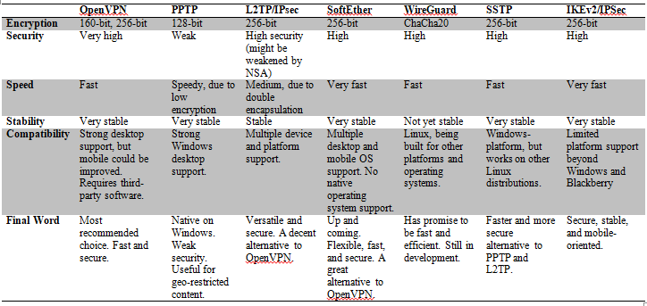

*Figure 2: Comparison between VPNS in terms of encryption, security, speed, stability and compatibility* **[15]**

But, how does OpenVPN provide these benefits?

In order to answer this question, a simple encrypted tunnel has been set up between two virtual machines in the lab. This has mainly been done to understand how OpenVPN works and the details regarding what the steps taken (alongside the rationale behind them, interesting observations, and the ways to verify/ test them) have been noted in points below:

1) Setup of the host configuration: In this step, the IP addresses present on the Ethernet interface (ens33) of the two VMs (virtual machines) have been obtained using the command **“ifconfig”**. After that, ping test has been performed using the command **“ping x.x.x.x”** where x.x.x.x was basically the IP address of VMs. This has been done to ensure that the TCP/IP protocols have been properly set within the VM (for self ping) and also ensure that the VMs can communicate with one another.

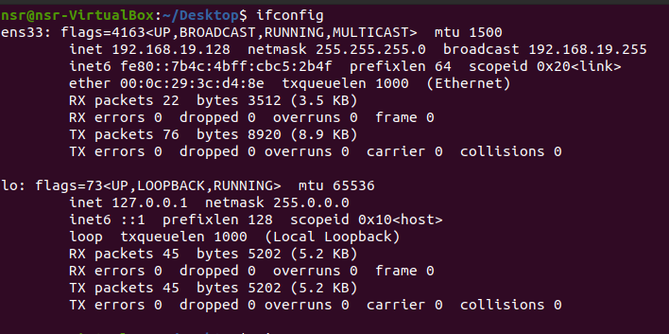

*Figure 3: IP address on ens33 for VM1*

*Figure 4: IP address on ens33 for VM2*

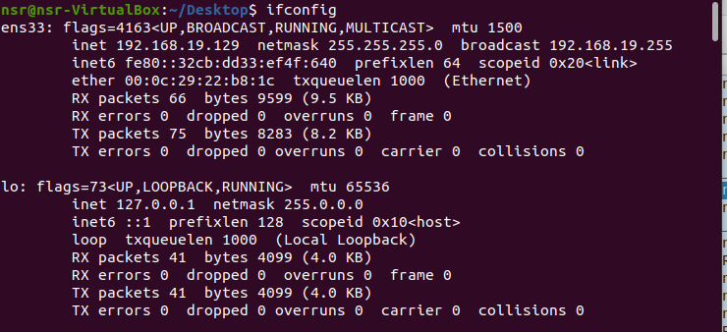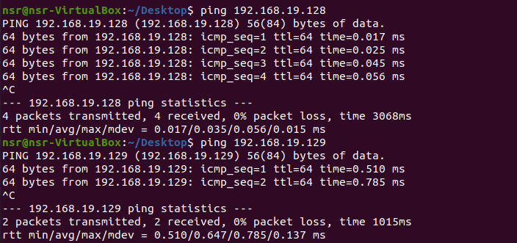

*Figure 5: Pinging on VM1*

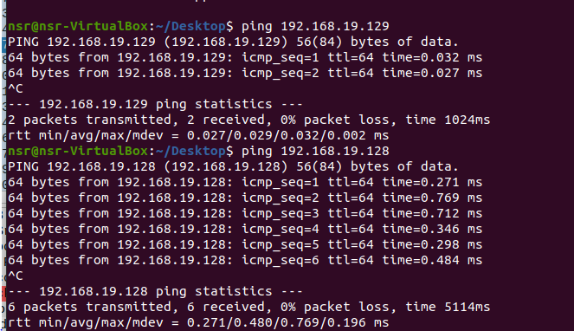

*Figure 6: Pinging on VM2*

2) Generate shared password: In this step, we create the shared password (of 256 byte or 2048 bit size) that would be used later on as a key to encrypt the traffic passing through the tunnel. This has been done by using the command “openvpn –genkey –secret mykey” which is basically asking OpenVPN to generate a secret key and save it in a file called mykey.

Once, this has been done, the process can be verified by using the command “cat mykey” which basically tells Linux to list out the contents in the file.

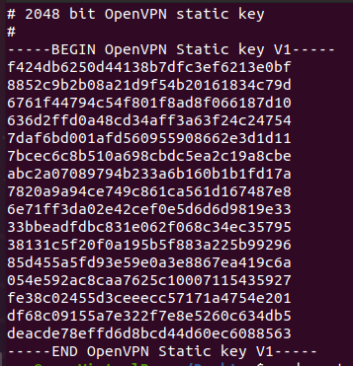

*Figure 7: The Openvpn key that have been generated and stored in the mykey file*

3) Transfer shared key to other machine: In this step, we use SCP (Secure Copy) to copy it from our current VM (VM1) to the other VM (VM2) that it can communicate with. This has been done as without the key, it would not be possible to set up the tunnel from the other end and thus would make the tunnel nonfunctional. This has been setup using the command “scp mykey nsr@192.168.19.129: Desktop/mykey” to ensure that the system sends the mykey file to the other machine’s nsr user’s desktop and stores it as mykey file there.

Once this has been entered (alongside the password of “user”), it will take a short time before stating it to be 100% complete (**as seen in the figure below**)



*Figure 8: SCP has been successful in sending the mykey file*

This can be further verified by checking the files on the desktop on VM2 (using the command “ls - al” which lists all the files in a long list format) and “cat’-ing the mykey file (**as seen in the figure below**).

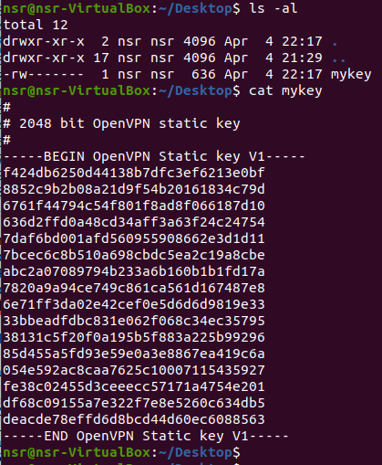

*Figure 9: Verification of the mykey file on VM2*

4) Setup of the encrypted tunnel: In this step, the OpenVPN encrypted tunnel has been set up on both VMs to ensure that the packets going both ways (VM1 ⇔ VM2) will be able to make use of the tunnel to encrypt themselves and thus prevent any form of Man-in-the-middle type attacks. This has been done by using the command “sudo openvpn –remote 192.168.19.129 –dev tun1—ifconfig 10.4.0.1 10.4.0.2 –verb 5 –secret mykey” on VM1 (which basically tells VM1 to set up a tunnel with VM2 where the end points will be 10.4.0.1 for VM1 and 10.4.0.2 for VM2, encryption will be set using mykey and reporting of messages passed will be set at a medium level using verb5) and “sudo openvpn –remote 192.168.19.128 –dev tun1—ifconfig 10.4.0.2 10.4.0.1 –verb 5 –secret mykey” on VM2 end(which basically tells VM2 to set up a tunnel with VM1 where the end points will be 10.4.0.2 for VM2 and 10.4.0.1 for VM1, encryption will be set using mykey and reporting of messages passed will be set at a medium level using verb5).

When this is entered on both ends, the VMs will take some time to process the information and setup the tunnel. Once that has been completed a new interface called “tun1” would be created on both interfaces and the following information would be displayed in the terminal:

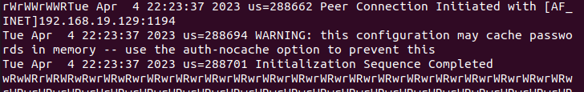

*Figure 10: How it looks in terminal once tunnel has been set*

5) Using the VPN tunnel: In this step, we will use the VPN tunnel to ping and telnet between the VMs. This would be done using the commands “ping x.x.x.x” and “telnet x.x.x.x” followed by username and password. In here, the x.x.x.x value would be 10.4.0.1 and 10.4.0.2 respectively as these are the endpoint IP addresses of the tunnel and we want to ensure that traffic can use the tunnel to pass the information between the VMs.

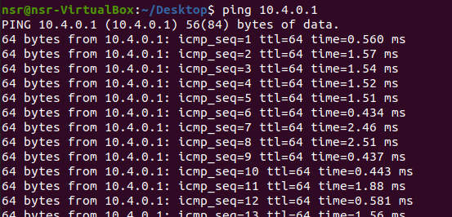

*Figure 11: Pinging the endpoints of the tunnel*

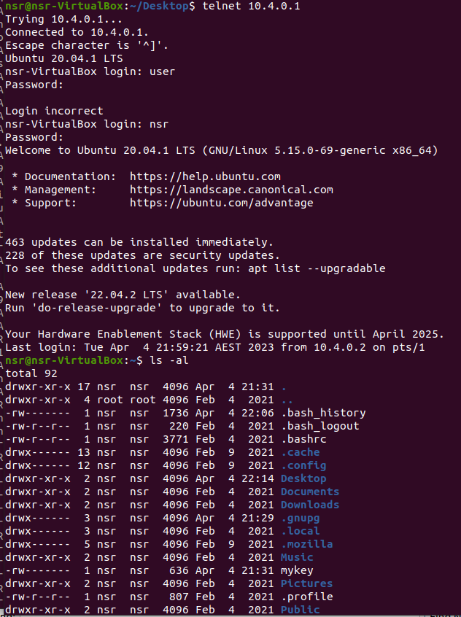

*Figure 12: Telnetting the endpoints of the tunnel*

During this time, Wireshark has been run on the side for both VMs observing both the ens33 interface (the actual interface between the VMs that packets are travelling through) and also the tun1 interface (the virtual tunnel interface set on the ens33 which the packets are using to encrypt themselves). This had resulted in the following interesting observations:

1) For both Ping and Telnet case, on both machines, although the wireshark on ens33 realized it was following OpenVPN protocol, it was not able to recognize what type of packet it was, nor the data that was being sent through it. Furthermore, it had considered those packets as Malformed and was also able to identify where those data were going (i.e the final source and destination IP).

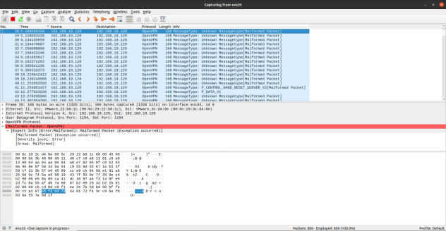

*Figure 13: ens33 not being able to properly detect the traffic*

2) On the other hand, the wireshark on tun1 was able to recognize the type of protocol that was being passed and see (and follow) all the data passing through the tunnel, but had identified the endpoint IP address of the tunnel as the source and destination addresses of the packets.

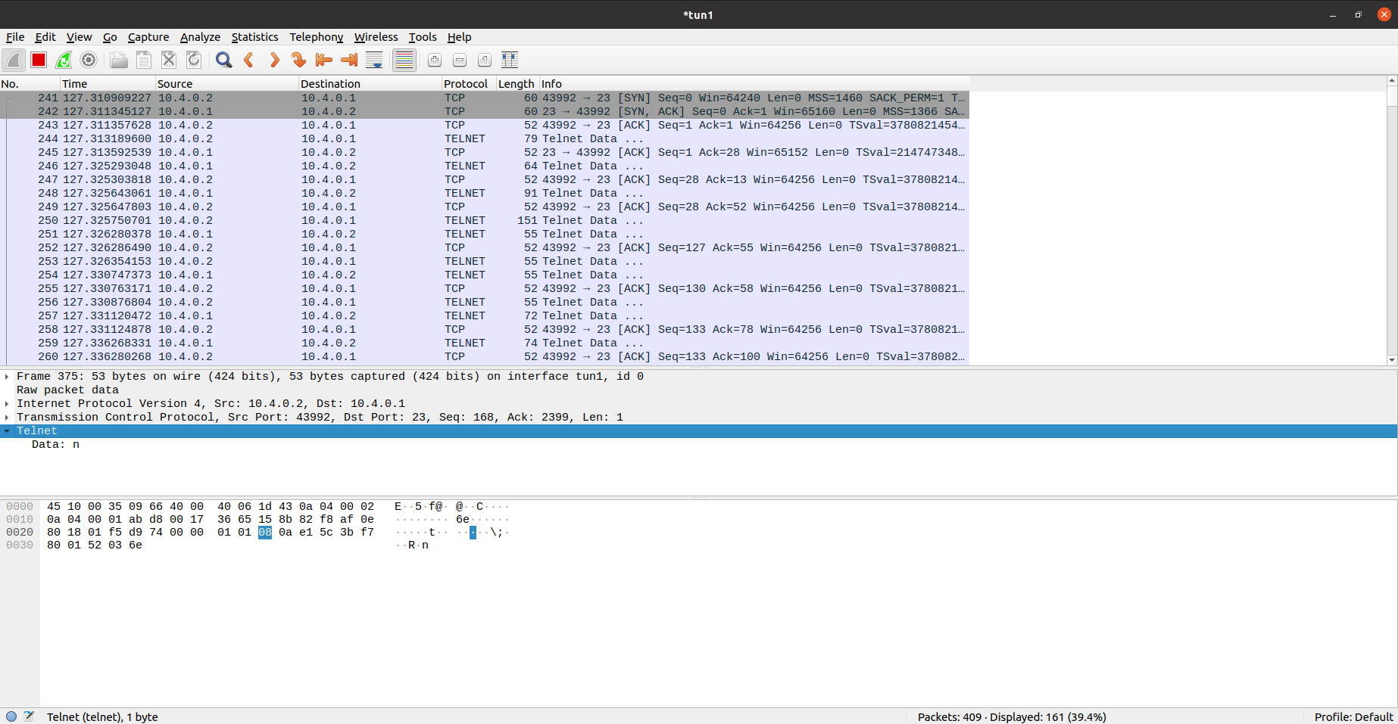

*Figure 14: tun1 being able to properly detect the traffic*

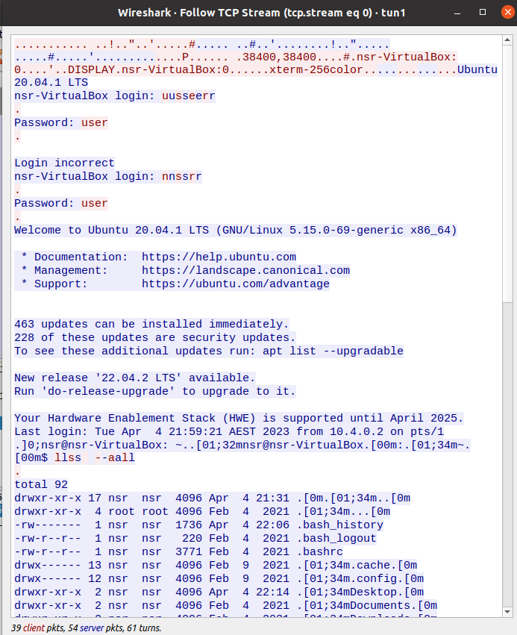

*Figure 15: tun1 being able to follow the traffic*

3) Moreover, in the case of telnet, ens33 had wrongly identified the Layer 4 header as UDP, whilst the tun1 had correctly identified the header as TCP.

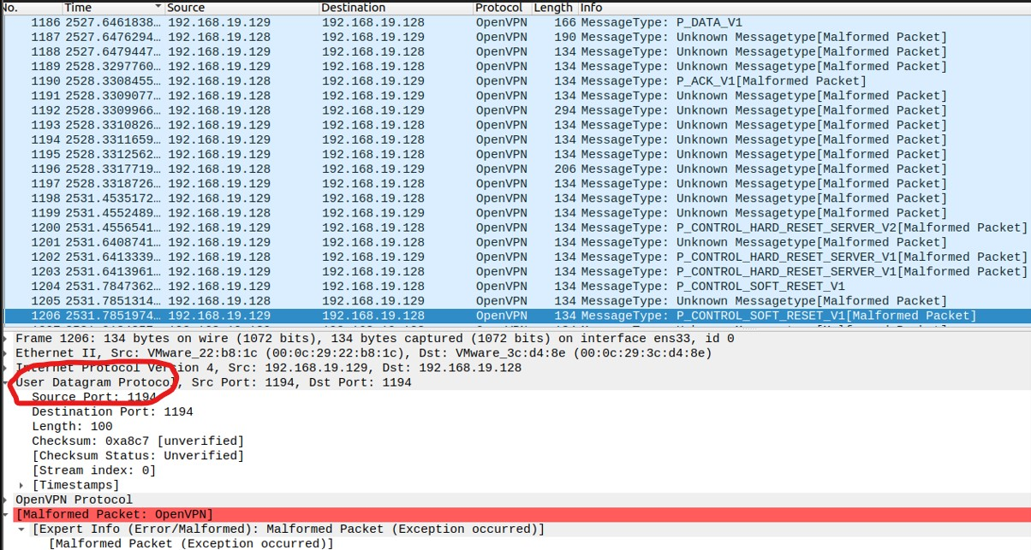

*Figure 16: end33 mistakenly thinks it is UDP*

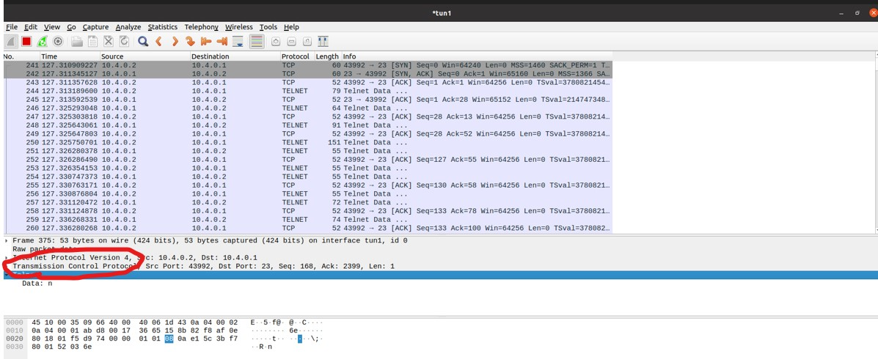

*Figure 17: tun1 correctly identifies it as TCP*

In order to understand why all these observations were found, one must first understand how the OpenVPN packet encapsulation works. This has been shown in using the general packet encryption (noted by T. Novickis **[16]** and L-A. Daniel, J.de Ruiter, E. Poll **[17]** which has been **shown in the** **figure below**:

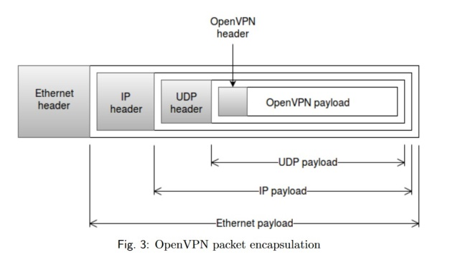

*Figure 18: OpenVPN packet encapsulation* **[16]**

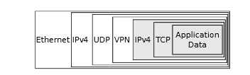

*Figure 19: Detailed OpenVPN packet encapsulation* **[17]**

By combining these two images we can get the following information:

At first, there is application data, which is encapsulated by TCP, which in turn is encapsulated by an IPv4 packet. This is in turn encapsulated by a VPN header and this entire section from **figure 19** is represented as OpenVPN header and OpenVPN payload in **figure 18**.

After this, the rest part is similar where the previously mentioned headers have been encapsulated by a UDP header, which in turn has been encapsulated by an IP header. After this, all of them are finally encapsulated by an Ethernet layer.

This shows that the observations made were actually sound as:

1) Ens33 only saw the packet from outside the tunnel and wasn’t able to break the encryption used to protect the payload inside the OpenVPN. Hence, it was only able to see where the packet was going and not what information or packet type was being passed.

2) Tun1 saw the packet from inside the tunnel and thus did not need to break any encryption. Hence it was able to see the information in the packet and the type of packets that was actually being passed inside the OpenVPN payload. Furthermore, it was saying 10.4.0.1 and 10.4.0.2 as the source and destination addresses as these were the endpoints assigned to the VMs on the tun1 end.

c) Ens33 thought it was a UDP packet. That’s because traffic going through the OpenVPN tunnel prefers to use Layer 4 header of UDP (on the protocol outside the OpenVPN header) for the packets **[9]** **[16]** to avoid “TCP meltdown issue” (as each TCP layer has its own transmission and congestion issue and interaction between the multiple TCP layers can lead to huge increase in congestion and delay) whilst hiding the fact that it’s actually using the TCP as layer 4 (on the protocol inside the OpenVPN header) for the packet. Thus, by not being able to see the information stored inside, ens33 had mistakenly assumed the entire packet to be a UDP one.

Conclusion  
Overall, in this report, a brief introduction to VPN tunnel, its tunneling protocols and its relevance to organizational security policy has been noted. After that, a brief explanation regarding OpenVPN has also been provided, along with the steps (including rational behind the steps and their verification processes) that are needed to set up a simple VPN tunnel.

Once, the VPN was fully set and functional, some interesting observations had been noticed on the interfaces associated with the setup. These had been later analyzed and explained with the help of OpenVPN’s packet’s encapsulation process.

But does this mean, OpenVPN has been completely explored though this process?

Not necessarily.

That’s because, here we only tested for transmission of “Ping” and “Telnet”. But we have not tested for other variations like IMAP, SSH, etc. Furthermore, we have also only tested with small traffic between two VMs, and not with huge traffic between several VMs (or between VMs that have several devices and machines connected in between them).

Hence, if the purpose of the lab was to only gain a basic understanding of how it works (and what it can and can’t do), then it has been fully successful. But if its aim was to ensure a complete and absolute understanding of everything OpenVPN can and can’t do, then it would be better to further extend the lab considering the factors that has been mentioned in the paragraph before.

# References

[1] A/Prof. P.Branch (2023). TNE30009/TNE80009 - Laboratory Session 3 [Portable document format (pdf)]. Available: <https://swinburne.instructure.com/courses/49751/pages/laboratory-week-6?module_item_id=3185485> . Accessed 20 Apr. 2023.

[2] Wikipedia Contributors. “Virtual Private Network.” *Wikipedia*, Wikimedia Foundation, 25 Apr. 2019, <https://en.wikipedia.org/wiki/Virtual_private_network> . Accessed 20 Apr. 2023.

[3] A/Prof. P.Branch (2023). Network Security and Resilience - VPNs - lecture fourteen [Portable document format (pdf)]. Available: <https://swinburne.instructure.com/courses/49751/pages/lectures-week-5?module_item_id=3185481> . Accessed 20 Apr. 2023.

[4] Microsoft Corporation. “Understanding Point-To-Point Tunneling Protocol (PPTP).” *Unipd.it*, 2022, <wwwdisc.chimica.unipd.it/luigino.feltre/pubblica/unix/winnt_doc/pppt/understanding_pptp.html>. Accessed 20 Apr. 2023.

[5] A/Prof. P.Branch (2023). Network Security and Resilience – Virtual Private Networks - lecture thirteen [Portable document format (pdf)]. Available: <https://swinburne.instructure.com/courses/49751/pages/lectures-week-5?module_item_id=3185481> . Accessed 20 Apr. 2023.

[6] IBM. “Layer 2 Tunnel Protocol.” *Www.ibm.com*, updated 11 Apr. 2023, [www.ibm.com/docs/en/i/7.4?topic=concepts-layer-2-tunnel-protocol](http://www.ibm.com/docs/en/i/7.4?topic=concepts-layer-2-tunnel-protocol). Accessed 20 Apr. 2023.

[7] utunnel.io. “OpenVPN vs IKEV2 vs L2TP- VPN Protocols Compared.” *Www.utunnel.io*, 11 June 2020, [www.utunnel.io/blog/vpn-technology/openvpn-vs-ikev2-vs-l2tp-vpn-protocols-compared](http://www.utunnel.io/blog/vpn-technology/openvpn-vs-ikev2-vs-l2tp-vpn-protocols-compared). Accessed 20 Apr. 2023.

[8] proofpoint. “What Is SSTP? - SSTP VPN Protocol & Security | Proofpoint AU.” *Proofpoint*, 16 Mar. 2022, [www.proofpoint.com/au/threat-reference/sstp. Accessed 20 Apr. 2023](http://www.proofpoint.com/au/threat-reference/sstp.%20Accessed%2020%20Apr.%202023).

[9] A/Prof. P.Branch (2023). Network Security and Resilience – VPNs - lecture fifteen [Portable document format (pdf)]. Available: <https://swinburne.instructure.com/courses/49751/pages/lectures-week-5?module_item_id=3185481> . Accessed 20 Apr. 2023.

[10] NCES. “Chapter 3-Security Policy: Development and Implementation, from Safeguarding Your Technology, NCES Publication 98-297 (National Center for Education Statistics).” *Ed.gov*, 2019, <https://nces.ed.gov/pubs98/safetech/chapter3.asp>. . Accessed 20 Apr. 2023.

[11] National Cybersecurity Society. *Virtual Private Network Policy Template*. 10 May 2019. Available: <https://nationalcybersecuritysociety.org/wp-content/uploads/2019/10/VPN-Policy-Template-FINAL.pdf> . Accessed 20 Apr. 2023.

[12] National Cybersecurity Society. “NCS Partner Portal | Meet Our Platinum Partners | NCS AU.” *Www.ncs.co*, 2021, [www.ncs.co/en-au/partners/](http://www.ncs.co/en-au/partners/). Accessed 20 Apr. 2023.

[13] wikipedia. “OpenVPN.” *Wikipedia*, 26 Feb. 2021, [https://en.wikipedia.org/wiki/OpenVPN.](https://en.wikipedia.org/wiki/OpenVPN.%20Accessed%2021%20Apr.%202023)  Accessed 21 Apr. 2023.

[14] Rimeikis, Antanas. “What Is OpenVPN and What Does It Have to Do with Your VPN?” *Surfshark*, 14 Nov. 2022, [https://surfshark.com/blog/what-is-openvpn.](https://surfshark.com/blog/what-is-openvpn.%20Accessed%2021%20Apr.%202023)  Accessed 21 Apr. 2023.

[15] Mardisalu, Rob. “Best VPN Protocols: OpenVPN vs PPTP vs L2TP vs Others (Comparison).” *TheBestVPN.com*, 9 June 2018, <https://thebestvpn.com/pptp-l2tp-openvpn-sstp-ikev2-protocols/>. Accessed 21 Apr. 2023.

**[16] T. Novickis. “Protocol state fuzzing of an OpenVPN”. Master Thesis, Faculty of Sciecne, Radboud University, Nijmegen in Netherlands, 2016 [**Portable document format (pdf)**]. Available:** [www.ru.nl/publish/pages/769526/tomas\_novickis.pdf](http://www.ru.nl/publish/pages/769526/tomas_novickis.pdf) Accessed 21 Apr. 2023.

[17] L. -A. Daniel, E. Poll and J. de Ruiter, "Inferring OpenVPN State Machines Using Protocol State Fuzzing," 2018 IEEE European Symposium on Security and Privacy Workshops (EuroS&PW), London, UK, 2018, pp. 11-19, doi: [10.1109/EuroSPW.2018.00009.](https://ieeexplore.ieee.org/document/8406556/authors) Accessed 21 Apr. 2023.